1. The cover photo can be a moving carousel with 4-5 images of jewellery.

Ref: Mercedes Benz website <https://www.mercedes-benz.com/en/>

1. The menu bar to be moved to the centre on top, right below the logo.

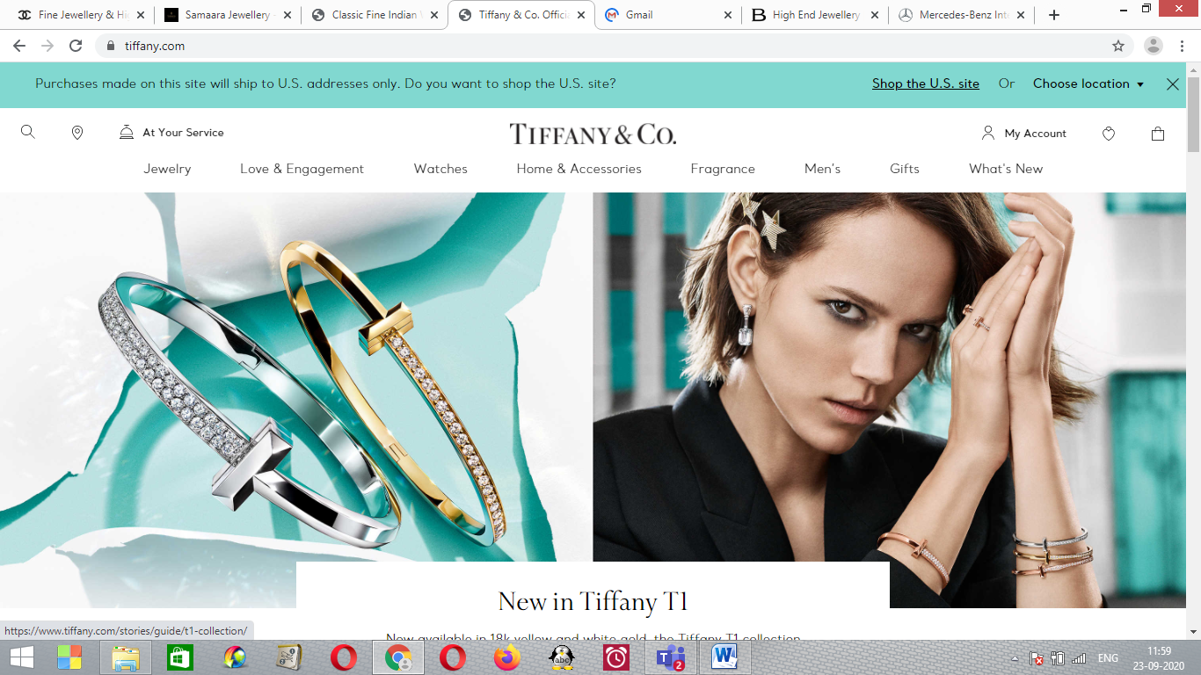

1. Menu bar order to be Home, Our Story, Jewellery Themes, Explore our work, Contact us
2. The background can be this one for the full website instead of complete black

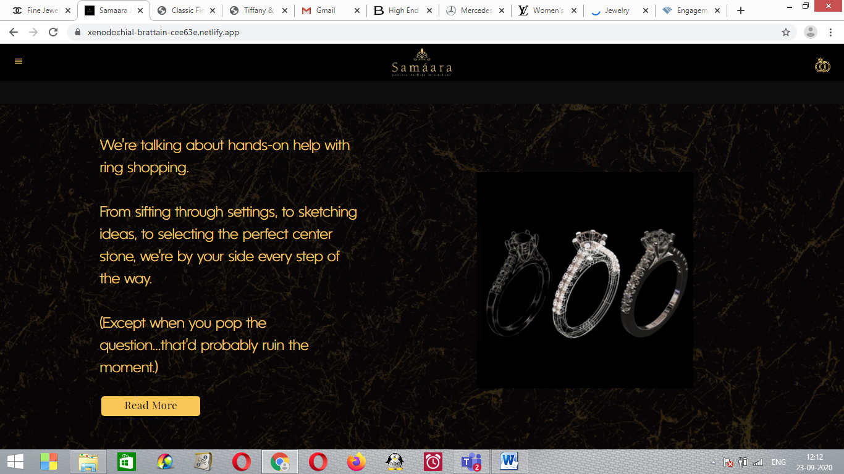

1. I liked the font used for Classic Jewellery, Transformative etc. We can either retain this or us the font used in Tiffany. The headings font size, the content font size all to be uniform.

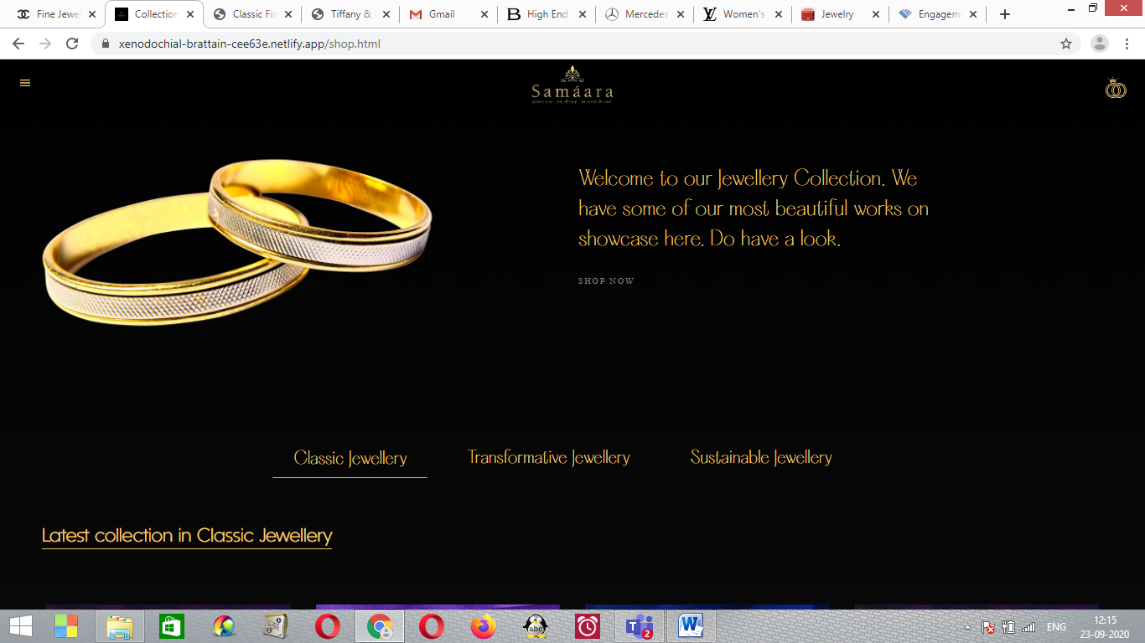

1. Can we have a provision of capturing client details such as name, email id, phone number etc when they start browsing the website?
2. The brand name Samaara to be made more visible. Refer to the tiffany website. Similar font size can be used.